 | AUTORITATEA AERONAUTICĂ CIVILĂ  A REPUBLICII MOLDOVA

AMC&GM la
CT – CE ATM/ANS

Mijloace acceptabile de punere în conformitate (AMC) și Materiale de îndrumare (GM)
la
Cerințe tehnice privind “Conformitatea echipamentelor ATM/ANS”

Ediția 02/ Februarie 2026
CUPRINS

INDEXUL AMENDAMENTELOR 2
REGULI DE AMENDARE 3
CAPITOLUL1. PREVEDERI GENERALE 4
1.1 Scopul 4
1.2 Domeniul de aplicare 4
1.3 Definiții 4
AMC1 to 1.3.2 of CT-CE ATM/ANS Statement of compliance 5
GENERAL 5
GM1 to 1.3.2 of CT-CE ATM/ANS Statement of compliance 5
GENERAL 5
GM1 to CHAPTER 2 of CT-CE ATM/ANS - CATEGORIES OF EQUIPMENT FROM THE POINT OF VIEW OF CONFORMITY ASSESSMENT REQUIREMENTS 6
AMC1 to CHAPTER 3 of CT-CE ATM/ANS Statement of compliance 7
REISSUE 7
GM1 to CHAPTER 3 of CT-CE ATM/ANS Statement of compliance 8
GENERAL INTERACTIONS AMONG INVOLVED PARTIES 8
AMC2 CHAPTER 3 of CT-CE ATM/ANS Statement of compliance 10
ISSUE 10
AMC3 to 2.4 CHAPTER 2 of CT-CE ATM/ANS Statement of compliance 10
ACTIVITIES 10
AMC4 to 2.4 CHAPTER 2 of CT-CE ATM/ANS Statement of compliance 10
RECORD-KEEPING 10
GM1 to 2.4 CHAPTER 2 of CT-CE ATM/ANS Statement of compliance 11
STANDARD FORM* 11
GM2 to 2.4 CHAPTER 2 of CT-CE ATM/ANS Statement of compliance 12
RESPONSIBILITY WHEN PURCHASING ATM/ANS EQUIPMENT SUBJECT TO SoC 12
GM3 to 2.4 CHAPTER 2 of CT-CE ATM/ANS Statement of compliance 12
DOCUMENTS 12
AMC1 to 3.2 CHAPTER 3 of CT-CE ATM/ANS Statement of compliance 12
SoC ISSUED BY DPO 12
ANNEX 1 13

INDEXUL AMENDAMENTELOR

Nr. crt. | Numărul ediției/ amendamentului | Data intrării în vigoare/nr. ordinului | Numele persoanei care a introdus amendamentul | Semnătura
1 | Ediția 01 | 01.05.2025/  № 13/GEN din 03.03.2025
2 | Ediția 02

REGULI DE AMENDARE

- Modificarea prevederilor AMC și GM se poate face numai prin amendament.

- Amendamentul se aprobă prin Ordinul Directorului Autorității Aeronautice Civile.

- După aprobarea amendamentului și publicarea Ordinului în Monitorul Oficial al Republicii Moldova, fiecare deținător al AMC și GM în cauză va introduce noile pagini emise și va distruge paginile înlocuite.

- Se emite o nouă ediție a AMC și GM dacă volumul modificărilor depășește 30% din conținutul acesteia.

CAPITOLUL1. PREVEDERI GENERALE

1.1 Scopul
Scopul prezentului document este de a furniza Mijloace acceptabile de punere în conformitate (AMC) și Materiale de îndrumare (GM) la Cerințe tehnice “Conformitatea echipamentelor ATM/ANS (CT-CE ATM/ANS), care transpun parțial Regulamentul delegat (UE) 2023/1768 al Comisiei din 14 iulie 2023 de stabilire a unor norme detaliate pentru certificarea și declararea sistemelor de management al traficului aerian/de servicii de navigație aeriană și a componentelor managementului traficului aerian/serviciilor de navigație aeriană, CELEX: 32023R1768, publicat în Jurnalul Oficial al UE L228 din 15 septembrie.

1.2 Domeniul de aplicare
Domeniul de aplicare al acestor AMC&GM corespunde Cerințelor tehnice “Conformitatea echipamentelor ATM/ANS (CT-CE ATM/ANS), care stabilesc cerințe referitoare la conformitatea sistemelor ATM/ANS și componentelor ATM/ANS utilizate de către furnizorii de servicii ATM/ANS certificați de AAC.

1.3 Definiții
În acest document se aplică definiții utilizate în CT-CE ATM/ANS.

AMC1 to 1.3.2 of CT-CE ATM/ANS Statement of compliance

GENERAL
The competent authority for the oversight of a statement of compliance (SoC) issued on request of an ATM/ANS provider by an organization involved in the design or production of ATM/ANS equipment (DPO) approved in accordance with 3.2 of technical requirements „Compliance of ATM/ANS equipment” (CT-CEATM/ANS) is the Civil Aviation Authority of the Republic of Moldova (CAA).

GM1 to 1.3.2 of CT-CE ATM/ANS Statement of compliance

GENERAL
As part of the support during the oversight activities, the ATM/ANS provider may request the presence of a representative of the approved DPO.

GM1 to CHAPTER 2 of CT-CE ATM/ANS - CATEGORIES OF EQUIPMENT FROM THE POINT OF VIEW OF CONFORMITY ASSESSMENT REQUIREMENTS
SCOPE OF ATM/ANS EQUIPMENT SUBJECT TO CERTIFICATION, DECLARATION AND STATEMENT OF COMPLIANCE

The table below provides a pictorial representation of which means of conformity assessment applies for the various types of ATM/ANS equipment.
No. | EATMN equipment, as defined in CT-CE ATM/ANS 1.2.1.2. | p.2.2 of CT-CE ATM/ANS  Certification of ATM/ANS equipment | p.2.3 of CT-CE ATM/ANS  Declaration of design compliance of the ATM/ANS equipment | p.2.4 of CT-CE ATM/ANS  Statement of compliance
 | The equipment should include in particular equipment required to support the following functions and services:
1. | airspace management (ASM) |  |  | X
2. | air traffic flow management (ATFM) |  |  | X
3 | air traffic services (ATS), in particular flight data processing systems, surveillance data processing systems and human-machine interface systems:
3 | 3a. controller-pilot communications | X
3 | 3b. air traffic control (ATC) services when enabling the separation of aircraft or the prevention of collisions | X
3 | 3c. other ATS equipment not covered in points 3a and 3b |  |  | X
4. | communications (COM) including ground-to-ground/space, air-to-ground and air-to-air/space communications:
4. | 4a. ground-to-ground communications |  | X
4. | 4b. air-to-ground communications  (i.e. controller-pilot communication) | X
5. | navigation (NAV) |  | X
6. | surveillance (SUR) |  | X
7. | aeronautical information services (AIS) |  |  | X
8. | meteorological services (MET) |  |  | X

AMC1 to CHAPTER 3 of CT-CE ATM/ANS Statement of compliance

REISSUE
(a) Having identified the need for a change (modification) to ATM/ANS equipment, the ATM/ANS provider or an approved DPO acting on its behalf should classify the change as minor unless one or more of the following apply, in which case the change is classified as major and a reissue of the SoC is required:
(1) The change (modification) includes one of the following technological evolutions:
(i) new concept of operation;
(ii) new technologies in the ATM/ANS equipment;
(iii) new or modified functionalities to the ATM/ANS equipment software;
(iv) changes in the ATM/ANS equipment hardware; or
(v) modified ATM/ANS equipment architecture.
(2) The change (modification) introduces new or modified means of compliance with the detailed specifications.
(3) The change (modification) introduces a modification in the limitation(s) to or a deviation from the detailed specifications.
(b) Minor changes should be processed according to the approved ATM/ANS equipment change management procedure ensuring that the change (modification) does not adversely affect the compliance with the detailed specifications (DS). For minor changes, the ATM/ANS provider should:
(1) record the change description and the justification for the change classification;
(2) update all related technical documents including the user manual;
(3) record continued compliance with the ATM/ANS equipment SoC.
(c) For major changes, the ATM/ANS provider should apply provisions of Chapter 3 of CT-CE- ATM/ANS and reissue a SoC.
(d) The procedure, which could be part of an integrated ATM/ANS provider’s change management procedure, addressing the changes (modifications) to ATM/ANS equipment should also include the process for the reaction by the ATM/ANS provider to an unplanned (major) change (modification) that may arise with the need for urgent action. This is the case in which the ATM/ANS provider responds immediately to a safety, security or interoperability problem or when an emergency situation arises in which the ATM/ANS provider has to take immediate action (e.g. security patches) to ensure the safety, security or interoperability of its equipment in operation.

GM1 to CHAPTER 3 of CT-CE ATM/ANS Statement of compliance

GENERAL INTERACTIONS AMONG INVOLVED PARTIES
(a) To issue a SoC for ATM/ANS equipment, the ATM/ANS provider must perform the necessary verification and test activities, as required. The CAA oversees the SoC as part of the management of changes to the functional system or during the continuous oversight of the ATM/ANS provider and, as necessary, applies enforcement measures to the ATM/ANS provider. Figure 1 shows the interactions between the regulated parties when the ATM/ANS equipment is subject to a SoC and such SoC is issued by the ATM/ANS provider.
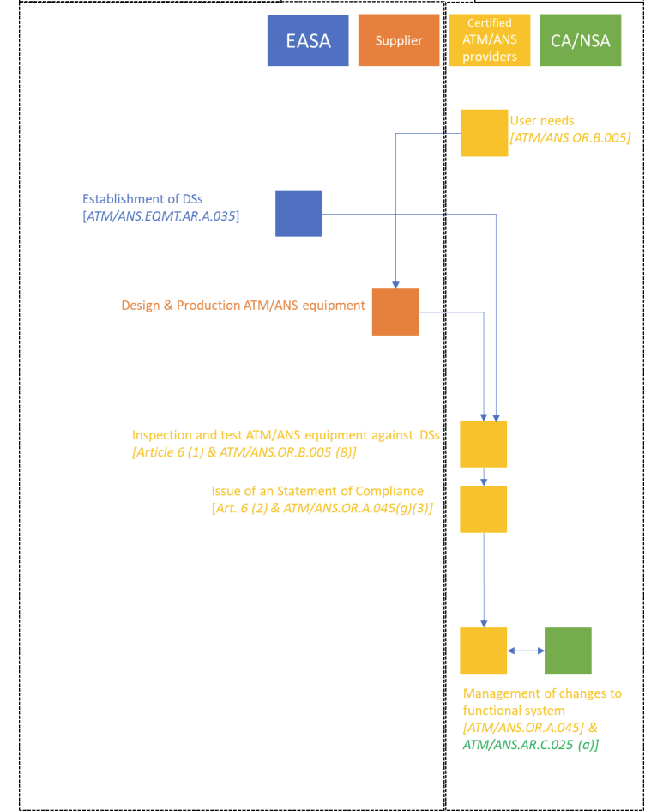

Figure 1
(b) A DPO can obtain privileges in accordance with the terms of the EASA approval to issue a SoC on behalf of an ATM/ANS provider, upon its request. There is an expectation that DPOs apply all processes and procedures under its EASA’s approval terms for such ATM/ANS equipment although this is not explicitly required, and thus, an EASA release form may be issued. Such EASA release form will provide additional assurance to the CAA that finished ATM/ANS equipment ready to be delivered has been manufactured in conformity with the design data. The CAA oversees the SoC as part of the management of changes to the functional system or during the continuous oversight of the ATM/ANS provider. If, during the continuous oversight of the ATM/ANS provider, the CAA identifies any non-compliance of the SoC, the CAA will inform EASA about any enforcement measures required. Figure 2 shows the interactions between the regulated parties when the ATM/ANS equipment is subject to a SoC and such SoC is issued by the DPO.
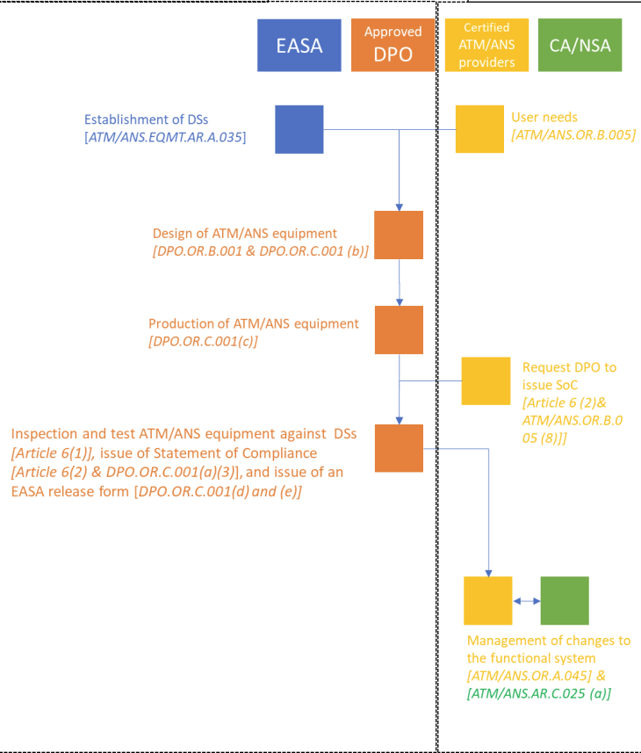

Figure 2

AMC2 CHAPTER 3 of CT-CE ATM/ANS Statement of compliance

ISSUE
- The SoC should contain the following information:
- a brief description, identification and scope of the ATM/ANS equipment;
- the Regulation reference requiring the issue of the SoC;
- the name and address of the certified, in accordance with the Regulation laying down technical and administrative requirements for ATM/ANS providers, approved by Government Decision 119/2023 (AMT/ANS Regulation), ATM/ANS provider, where the ATM/ANS equipment will be deployed or on its behalf, the trade name and full address of the approved DPO issuing the SoC;
- the reference to the detailed specifications adopted by EASA in accordance, as far as applicable, for the intended use, and any deviations therefrom;
- the reference to the procedure followed in order to declare compliance with the applicable ATM/ANS equipment detailed specifications;
- deviations;
- remarks;
- limitations;
- conditions;
- date and version;
- identification of the signatory.
(b) The SoC should be accompanied by all documents that form the basis for the issuance of it and, when issued by an approved DPO, an EASA release form issued by the same DPO.

AMC3 to 2.4 CHAPTER 2 of CT-CE ATM/ANS Statement of compliance

ACTIVITIES
The ATM/ANS provider should verify the functionalities of the ATM/ANS equipment subject to conformity assessment in accordance with 2.4 of CT-CE ATM/ANS to ensure that it complies with the applicable detailed specifications in the context in which it is intended to operate within the functional system.

AMC4 to 2.4 CHAPTER 2 of CT-CE ATM/ANS Statement of compliance

RECORD-KEEPING
(a) In the context of ATM/ANS.OR.B.030 of the ATM/ANS Regulation, a copy of the SoC should be kept by the ATM/ANS provider throughout the service life of the ATM/ANS equipment and should be provided to the CAA upon request.
(b) The ATM/ANS provider should keep the records for a period of at least 3 years after the end of the service life of the ATM/ANS equipment unless otherwise specified by other applicable requirements.

GM1 to 2.4 CHAPTER 2 of CT-CE ATM/ANS Statement of compliance

STANDARD FORM*
SoC No [internal numbering]
Issue No [version of this SoC]

1. Name and address of ATM/ANS provider.
2. Description, identification and scope of the ATM/ANS equipment.
Note: It should include e.g. type, SW/HW version number and master drawing record, as applicable.
3. Regulation reference requiring the issue of the SoC.
4. Specification reference, i.e. EASA detailed specification No.
5. Reference to the qualification test report to show compliance with the applicable detailed specifications and the procedure followed in order to be compliant.
6. Service and instruction manual reference number.
7. SoC with the applicable EASA detailed specification, as far as applicable for the intended use, and any deviations, remarks, limitations, conditions.
8. The declaration in this document is made under the authority of ………………………………… (Name of ATM/ANS provider or approved DPO).
(approved DPO’s name) cannot accept responsibility for equipment used outside the limiting conditions stated above without their agreement.
Date: …… Signed……………(ATM/ANS provider’s or approved DPO’s authorised representative)

* see also Annex 1

GM2 to 2.4 CHAPTER 2 of CT-CE ATM/ANS Statement of compliance

RESPONSIBILITY WHEN PURCHASING ATM/ANS EQUIPMENT SUBJECT TO SoC
(a) The procurement contract between the ATM/ANS provider and the manufacturer(s) should clearly define the ATM/ANS equipment to be purchased and the applicable detailed specifications.
(b) The contract should address that the ATM/ANS equipment purchased from the manufacturer(s) is manufactured and verified and the ATM/ANS functions thereof have been tested for the intended use.

GM3 to 2.4 CHAPTER 2 of CT-CE ATM/ANS Statement of compliance

DOCUMENTS
The documents that form the basis for the issuance of the SoC encompass, but are not limited to:
(a) test results; and
(b) descriptions of the test environment.

AMC1 to 3.2 CHAPTER 3 of CT-CE ATM/ANS Statement of compliance

SoC ISSUED BY DPO
During the oversight activities on a SoC issued by an approved DPO, that DPO should support the ATM/ANS provider to the extent required.

ANNEX 1

Company Logo | Equipment reference | Document reference | REV. No
Company Logo | Equipment reference | Document reference | REV. Date

ATM/ANS Statement Of Compliance (SoC) of
XXXX

Document Identifier^{(*)}

// When the ATM/ANS equipment embeds multiple functions being across different articles 2.2, 2.3, 2.4 CT-CE ATM/ANS then the conformity assessment should follow the most demanding demonstration (i.e. in the following order from most to less stringent method: Certificate, declaration of design compliance or SoC).

(*) i.a.w. the numbering system defined in the DPO management system.

Company Logo | Equipment reference | Document reference | REV. No
Company Logo | Equipment reference | Document reference | REV. Date

1. REVISION HISTORY

Rev. No | Rev. date | Affected section or pages | Description

2. INTRODUCTION
This document represents the Statement of Compliance of the ATM/ANS equipment per Article 2.4 of CT-CE ATM/ANS.

i.e. SoC is used to conclude and state compliance with CT-CE ATM/ANS and applicable Detailed Specifications for the ATM/ANS Equipment - SD&AMC&GM-DS-GE.SoC. This document is signed and dated by the organization responsible for its issuance per CT-CE ATM/ANS.

3. NAME AND ADDRESS OF ANSP / DPO
Provide the name and address of ATM/ANS provider or of DPO in case of SoC delegated to and issued by a DPO).
Provide also the name and address of the Manufacturer, if different from organization responsible for Design.

4. ATM/ANS EQUIPMENT DESCRIPTION AND IDENTIFICATION

ATM/ANS equipment designation:
Model name: ………………..
Part number(s): …………………………..

Note 1: when several part numbers/constitute the ATM/ANS equipment, the part number of each constituent should be listed. In particular, for ATM/ANS equipment embedding software component for which the configuration is not set by the hosting hardware part-number, the software loadable part number(s) should be identified. A compatibility matrix or equivalent information should be issued showing the authorized configurations.

List ALL functions embedded into the ATM/ANS equipment, including those additional functionalities that do not have any corresponding section in the applicable Detailed Specifications.

Company Logo | Equipment reference | Document reference | REV. No
Company Logo | Equipment reference | Document reference | REV. Date

Note 2: in this document the term equipment refers to what system or constituent is declared. Depending on the scope of the statement of compliance the term ‘equipment’ may correspond to a physical unit performing the complete function as well as for constituent of a function (e.g. software) for which it was found acceptable to elect to comply to the function, but as ‘incomplete function’.

4.1 Change impact analysis (case of minor change)
When the equipment is a minor change to an equipment for which an SoC has already been issued, provide the reference of the SoC and describe the change in details. Change impact analysis information should be provided so as to allow evaluation of the change classification.

5. SOC ATTESTATION BASIS
Define the revision of the Detailed Specifications applicable at date of issue of the SOC.
Define the applicable functions within Detailed Specifications. For each identified function (e.g. please use the taxonomy (GT-DS-GE.SoC) SOC.ABCD.v, SOC.VXYZ.i…available on CAA website), also include the applicable General requirements and applicable AMC, including reference to used standards, and the applicable issue of the Detailed Specifications (AMC&GM, DS-GE.SoC).

Define any Special conditions applicable to the equipment functions.

Identify the DS function with the attribute “incomplete” when the equipment doesn’t perform all features of the functions and need to be complemented by other equipment to complete the function and demonstrate the full performance (e.g. when the equipment is only the software part implementing the function).

5.1 Assurance levels
Software and Electronic Hardware
Define the applicable requirements and related standards (identified in Detailed Specifications) followed for the development of software and Electronic Hardware, in accordance with the Software Assurance Level and the Hardware Assurance Level.

Equipment Assurance
Define the applicable assurance for the development of the equipment and related standards (if any).

6. RATED PERFORMANCE
Declare the equipment type or class, if any.
Declare key performance ratings of the equipment, range and accuracy…. Including the environmental conditions over which the equipment has been tested to perform its intended function.

For radio transmitters the transmitting frequency band, maximum transmitting power, and emission designator (ETSI or FCC).
Weight and overall dimensions of the equipment.

Company Logo | Equipment reference | Document reference | REV. No
Company Logo | Equipment reference | Document reference | REV. Date

7. DEVIATIONS
Declare the deviations of the equipment to comply with the Detailed Specifications.

Note: Deviations should be requested and accepted by the competent authority)/ preferably prior to use into an SoC.

Note: When there isn’t any deviation to the Detailed Specification for the ATM/ANS equipment, it is still worth having a section to mention it (i.e. None).

8. LIMITATIONS

Any known limitations (including known open problem) which may limit the performance in the intended installation e.g., restrictions in mounting attitude or non-compliance to the equipment specification, installation limitation…

When the equipment subject to Statement of compliance is only a constituent of the function (e.g. Software only equipment), declare a limitation on the equipment to be installed with the rest of environment that complete the function (e.g. targeted hardware, operating system etc). Note that these are expected to be used for testing the ‘equipment’ function.

Note: When there isn’t any limitation to the ATM/ANS equipment, it is still worth having a section to mention it (i.e. None).

9. COMPLIANCE DEMONSTRATION

List all the data supporting the compliance demonstration:

- Provide reference to the compliance matrix where more details about requirements, means of compliance and compliance data are provided;
- Reference to the certification programme for the ATM/ANS equipment with identification of the deviations from the certification programme;
- Reference to compliance reports (test plans/-reports, other qualification reports);
- Reference to the safety documents (Failure Mode Effect Analysis, SEU analysis, SSA) relevant to the article;
- Reference to Service and Instruction Manual, Installation Manual, Maintenance Manual and Operation Manuals reference;
- Reference to the Master Drawing.

10. MARKING

Provide the label template for all equipment under the SoC

Company Logo | Equipment reference | Document reference | REV. No
Company Logo | Equipment reference | Document reference | REV. Date

11. EASA RELEASE FORM TEMPLATE PRE-FILLED WITH THE ATM/ANS EQUIPMENT DATA

This section is optional but strongly recommended when the SoC is release by a delegated DPOA Holder.

ATM/ANS EQUIPMENT RELEASE FORM
1. DPO name |  | 2. Form Tracking No:
3. ATM/ANS equipment serial number
4. ATM/ANS equipment model name

5. Part number |  | 6. Statement Ref No:
7. Description of the ATM/ANS equipment
8. Concessions
9. Exemptions, waivers or derogations
10. Remarks
11. Statement of Conformity
It is hereby certified that this ATM/ANS equipment conforms fully to the certificated design/the declaration of design compliance and to the items above in boxes 7, 8, 9 and 10.
The ATM/ANS equipment is manufactured in compliance with Implementing Regulation (EU) 2023/1769.

12. Signed | 13. Name |  | 14. Date (d/m/y)
15. DPO Approval Reference

The above EASA release form is to be pre-filled in accordance with the information provided in the Statement of Compliance (Model name, PN, DPO approval number, etc…).

12. STATEMENT OF COMPLIANCE

It is hereby declared that:
- The ATM/ANS equipment has been designed in compliance with CT-CE ATM/ANS;
- the ATM/ANS equipment complies with the attestation basis defined in section 5;
- no feature or characteristic has been identified that may render the ATM/ANS equipment unsuitable for its intended use; and
- the features, characteristics or functions that do not form part of the SoC attestation basis have no interference or detrimental effect on the suitability of the ATM/ANS equipment for its intended use.
Company Logo | Equipment reference | Document reference | REV. No
Company Logo | Equipment reference | Document reference | REV. Date

This declaration/statement is made under the authority of
……………………………………………………………………………………………………………..…
(name of ATM/ANS provider or if delegated, name of DPOA Holder).

In case of SoC issued by the DPO Holder:
DPOA Holder cannot accept responsibility for equipment used outside the limiting conditions stated above without their agreement.

Date: …………. Signed…………………………………………………….
(Authorised representative of ANSP/DPOA Holder* with DPOA reference number)

^{(*)} Authorised signatories shall be as defined in the procedures of the management system of the ANSP/DPOA holder.

A ‘new’ version is introduced in the case of major changes.

